How to log into Canvas with Microsoft Authentication
(No more ID numbers!!)

- Navigate in a web browser to https://cbc.edu
  - Go to:
- Quick Links
- My CBC Portal
- Canvas
Alternatively, you can get to the Canvas login directly using: https://centralbaptist.instructure.com/login/saml

You will be taken to a Microsoft login screen
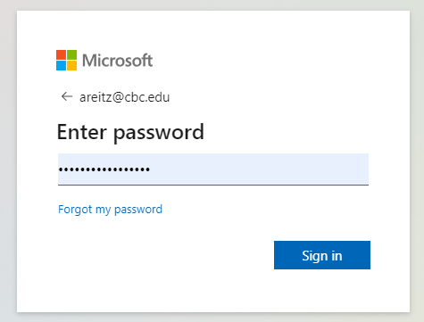

- Select or enter your @cbc.edu email address and enter your password. This will be the same password as your Office 365/Outlook email account.
- You will likely have already set up multi-factor authentication on your account. Go ahead and authenticate through your phone number (or another method)
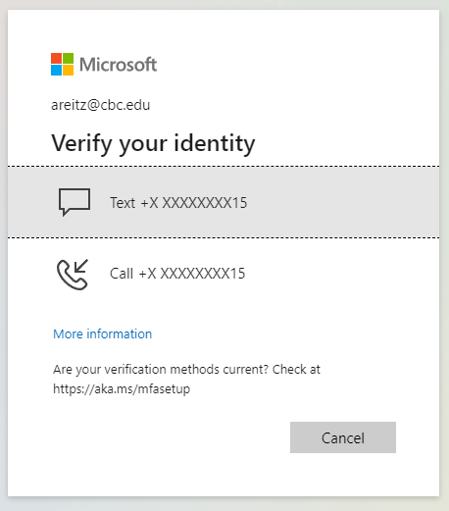

- Select the option to stay signed in, that way you don’t need to verify your identity every time you go to Canvas.
- And that’s it! This will be the proper and preferred method to log into Canvas moving forward.

If you have any questions please contact the IT Department at techsupport@cbc.edu OR call at 501-205-8787

