New CBC account security information

Set up Security info from a sign-in page
Follow these steps when you're prompted to set up your security info immediately after you sign-in to your account
You'll see this prompt only if you haven't set up the security info required.

Security verification versus password reset authentication
Security info methods are used for both two-factor security verification and for password reset. However, not all methods can be used for both. We have 3 methods available for account authentication and password reset.
Method | Used for
Text message/Phone call | Two-factor verification and password reset authentication.
Email account | Password reset authentication only.
Security questions | Password reset authentication only.

Sign in to your account
After you sign in, you'll see a prompt that asks you to provide more information before it lets you access your account.
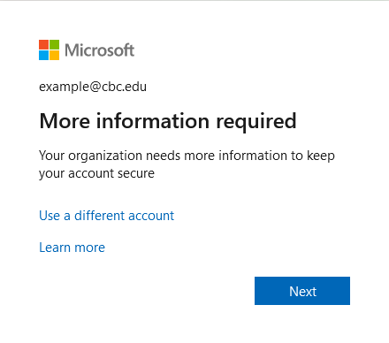

Set up your security info using the wizard
Follow these steps to set up your security info for your account.
- After you select Next, a Keep your account secure wizard appears, showing the first method you will need to set up. In our case, it’s the text message/phone number method.
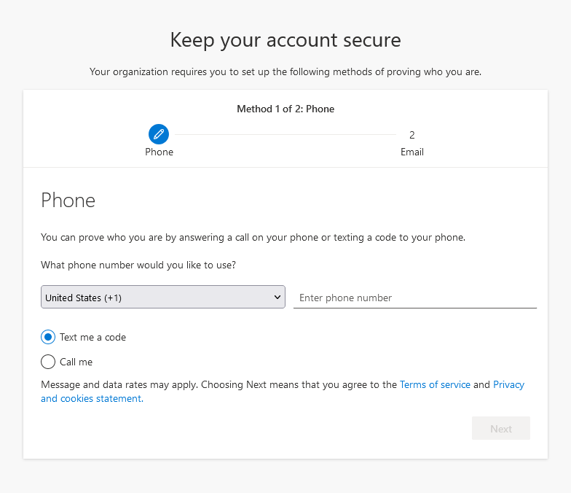
- On the Phone set up page, choose whether you want to receive a text message or a phone call, and then select Next. In this example we're using text messages, so you must use a phone number for a device that can accept text messages. A text message is sent to your phone number. If would prefer to get a phone call, the process is similar.
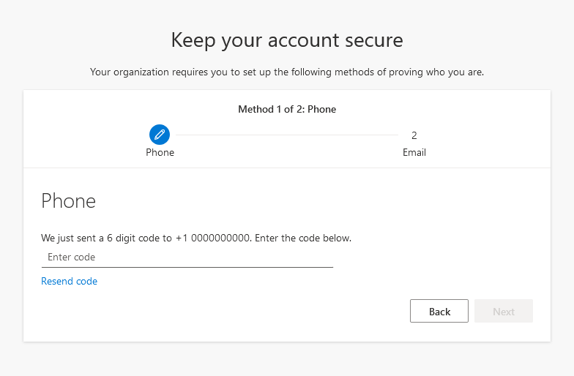
- Enter the code provided by the text message sent to your mobile device, and then select Next.
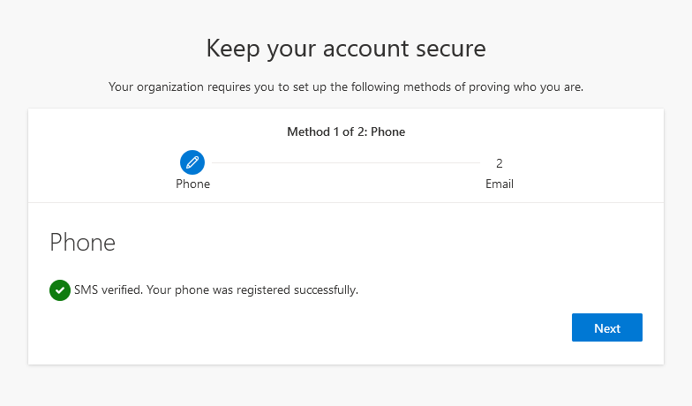
- Review the success notification, and then select Next.
- The email setup page appears.
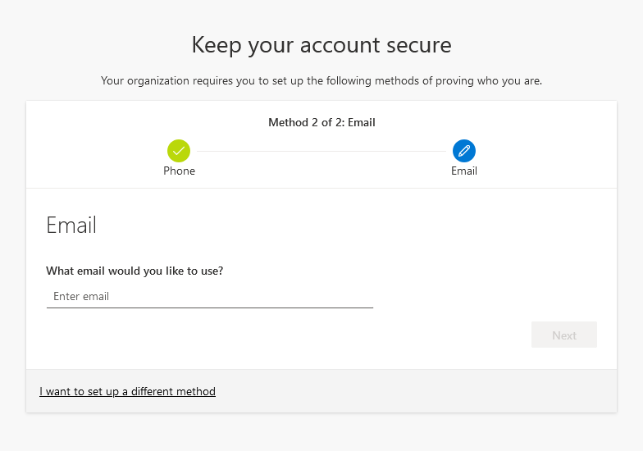
- Enter an alternative email address to use for password recovery. This cannot be an @cbc.edu email address.
- Select Next. An email will be sent to the provided address containing a code.
- Enter the code to verify your alternative email address
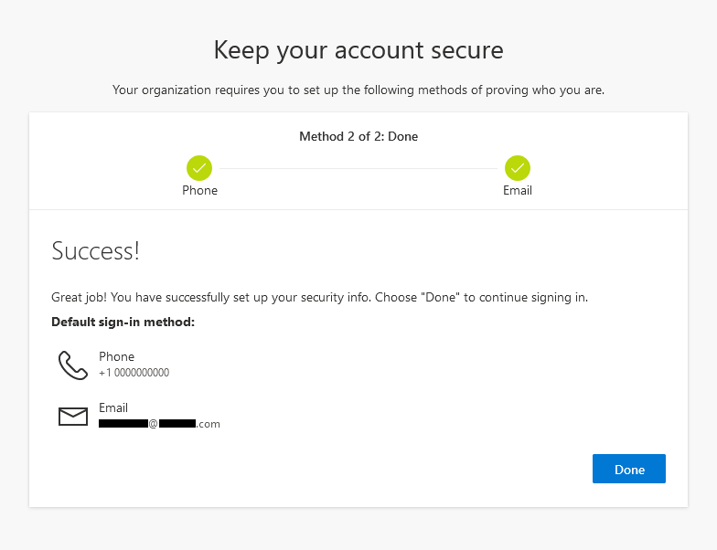
- Review the Success page to verify that you've successfully set up both a phone number (either text message or phone call) and an alternative email address for your security info, and then select Done.
- If you used the default password ‘CBCMustangs2022!’ to log in, here you will be asked to change it. Please refer to the password requirements in the ‘Passwords’ documentation.
- You have now successfully registered your account for two-factor authentication and password recovery.
You may recover your password anytime by clicking ‘Forgot my password’ on the initial sign-in page. You will use your provided security info to recover your password.

Next steps
- Review the ‘How to log into Canvas with Microsoft Authentication’ and ‘Passwords’ documentation.
- Contact the IT department if you have any questions at all
  - techsupport@cbc.edu
  - 501-205-8787

